Front-end “React- Components,State,Props”

Parmar Sachin Jagdish Bhai.

**1.React-Component**

**ANS -** A component is a self-contained piece of code that defines a part of a user interface. Components can be reused and composed to build complex UIs. In React, components can be either class components or functional components.

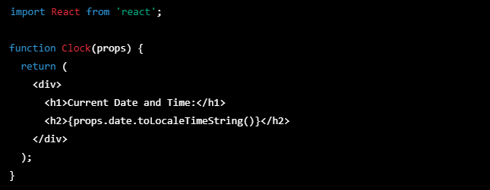

**2.React-State**

**ANS -** State is an object that stores data that can change over time within a component. When the state changes, the component re-renders and updates the UI to reflect the new state. State can only be updated using the **`setState`** method and should not be modified directly.

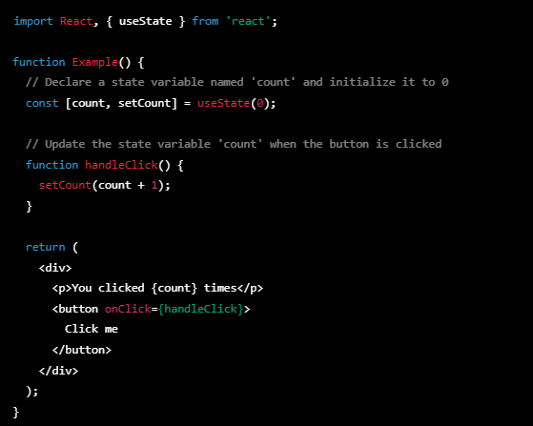

**3.React-Props**

**ANS -** In React, `**props`** (short for properties) are used to pass data between components. They allow a parent component to pass data down to its child components, which can then use that data to render their output.

